University of Wolverhampton
School of Mathematics and Computer Science
5CS022 Distribute and Cloud Systems Programming
Workshop 3 The Akka Framework
Overview
This workshop continues the exploration of the Akka Framework from the previous tutorial.
1. The Actor class Actors in the sample Akka program currently responds to only one message object – MessageA. Modify the createReceive() method so that it will also respond to any other message and print out the message on the standard output.

Program:
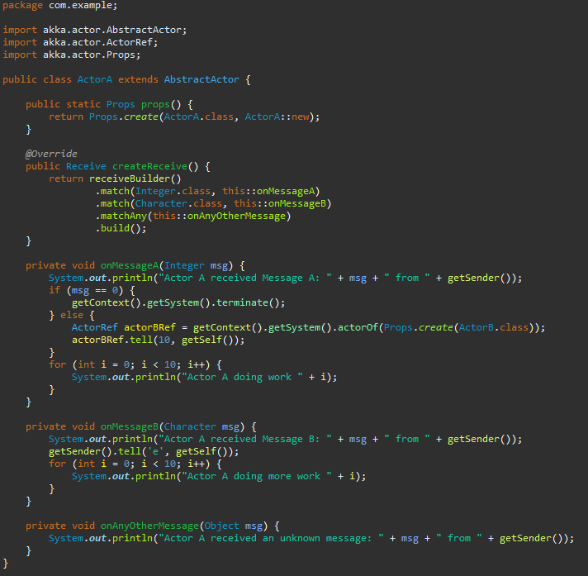
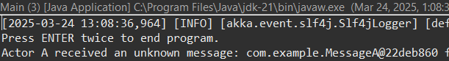
Explanation: This Akka actor, ActorA, is designed to handle three types of messages. If it receives an Integer, it processes the message in the onMessageA method, where it prints the message and, if the value is 0, terminates the actor system. Otherwise, it creates a new actor (ActorB) and sends it a message. If ActorA receives a Character, it processes it in onMessageB, prints the message, responds with 'e', and performs additional work. For any other message type, the onAnyOtherMessage method logs the received message, ensuring the actor handles unexpected inputs gracefully.
2. Every message in Akka is a Java object. However, not all messages need to have a custom Java class created for them. Convert the sample program so that it can respond to messages that contain the primitive data types such as byte, short, int, long, float, double, boolean, and char, without having to create custom Java classes.
Program:
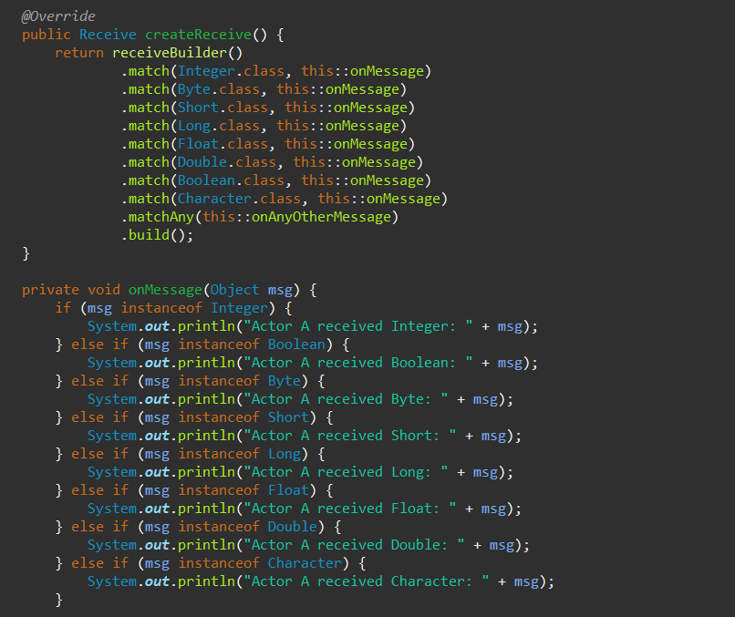

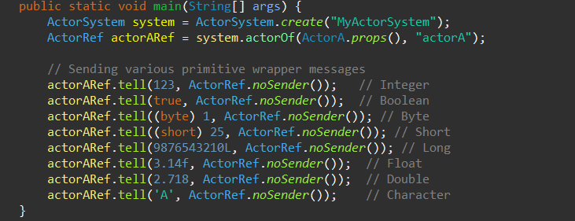

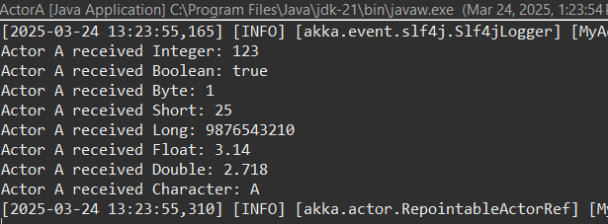

Explanation: This Akka actor program defines ActorA, which can receive and process various primitive wrapper types such as Integer, Boolean, Byte, Short, Long, Float, Double, and Character. The createReceive method specifies handlers for each data type, directing them to the onMessage method. Inside onMessage, the actor identifies the message type, prints it, and performs additional actions such as terminating the system if it receives an Integer value of 0 or forwarding a message to ActorB if it receives another Integer. The main method initializes an actor system and sends test messages of different types to ActorA.
3. Create 2 Akka Actor classes "ActorA" and "ActorB" to demonstrate the Akka API setReceiveTimeout().ActorA will generate a random integer number from 1 to 5 in a loop for 100 times, and send this integer as a message to ActorB, which would then call Thread.sleep() that many seconds. Set the receive timeout to 2 seconds, and when the timeout triggers, send ActorB a stop() message, and then create a new instance of ActorB to process the next number.

Assessed Task
1. Create 3 Akka Actor classes called "Producer", "Supervisor" and "Worker". The "Producer" will generate 1000 random long integer numbers between 10000 and 100000. The "Producer" will send each number as a message to "Supervisor".
At start-up, the Supervisor will create 10 "Worker" Actors. When the "Supervisor" receives a number from the "Producer", it will use the API forward() to forward that message to one of the "Worker" actors, in a round-robin fashion.
The "Worker" actor will determine if the number in the message is a prime number. If it is a prime number, it will then send a string/text message to the "Producer", saying that "The number XXX is a prime number." And the Producer will print out the message on the standard output.
When the 1000 numbers have been produced and checked, the "Producer" actor will terminate the Actor system.
Export your project as a Zip file (either IntelliJ or Eclipse) and submit this program as "workshoptask3.zip" as part of your final portfolio submission. You can also upload it to the formative submission point for formative feedback.

